### ****Report about Multiple Inheritance****

### ****1. What is Multiple Inheritance?****

Multiple inheritance is a feature in object-oriented programming (OOP) where a class (child/subclass) can inherit attributes and methods from **more than one parent class**.

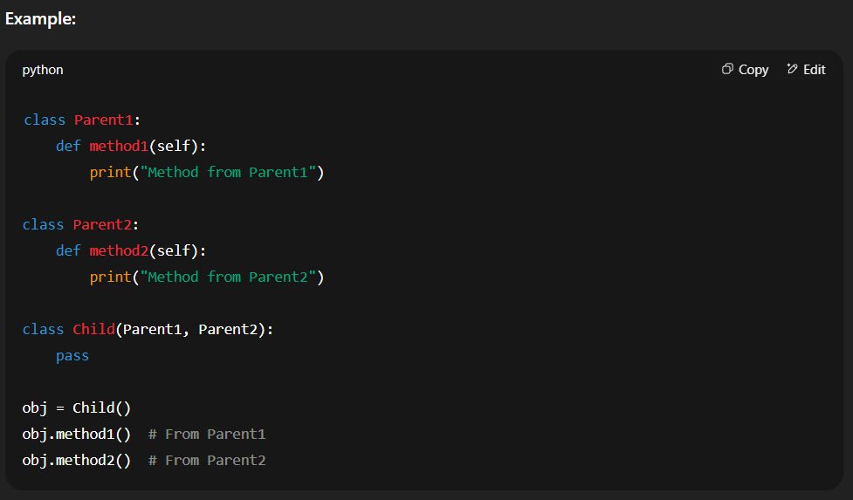

### ****2. What will happen if the child and the parent have the same method?****

If the child class defines a method with the same name as one in its parent(s), the **child’s method overrides** the parent’s method. This is known as **method overriding**.

**Method overriding (MRO):** Method overriding is an ability of any object-oriented programming language that allows a subclass or child class to provide a specific implementation of a method that is already provided by one of its super-classes or parent classes. When a method in a subclass has the same name, the same parameters or signature, and same return type(or sub-type) as a method in its super-class, then the method in the subclass is said to override the method in the super-class.

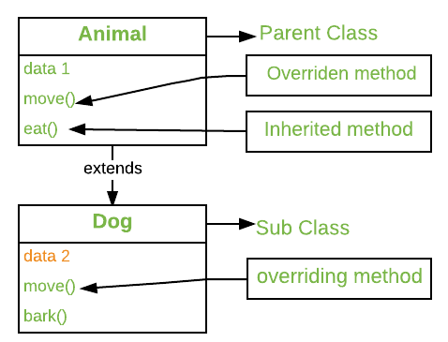

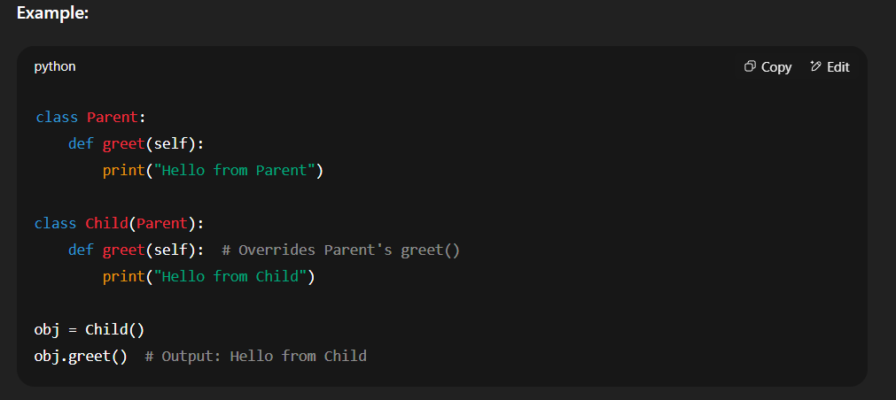

### ****3. What if two parents have the same parent? (Diamond Problem)****

If two parent classes share a common ancestor, Python uses **C3 linearization** to ensure each class is only visited once in the MRO, avoiding duplicate calls.

**C3 linearization: C3 Linearization is a method used in Python to figure out the order in which classes should be checked when looking for a method or attribute in a hierarchy of classes. It’s especially helpful in situations where a class inherits from multiple other classes (known as multiple inheritance). The goal of C3 Linearization is to make this process consistent, predictable, and free from confusion, even when the relationships between classes are complex.C3 Linearization is a method used in Python to figure out the order in which classes should be checked when looking for a method or attribute in a hierarchy of classes. It’s especially helpful in situations where a class inherits from multiple other classes (known as multiple inheritance). The goal of C3 Linearization is to make this process consistent, predictable, and free from confusion, even when the relationships between classes are complex.**

